|  |  |  |  |
| --- | --- | --- | --- |
| **paf_kiet_logo** | **COLLEGE OF COMPUTING AND INFORMATION SCIENCES** | | |
| **Final Assessment of Lab Exam (Spring 2021 Semester)** | | |
| **Class Id** | 106293 | **Course Title** | BASIC ELECTRONICS LAB |
| **Program** | BSCS | **Campus / Shift** | MAIN MORNING |
| **Date** | 20-04-2021 | **Total Marks** | 20 |
| **Duration** | 2.5 hours | **Faculty Name** | M.HARIS |
| **Student Id** | 12113 | **Student Name** | Shahmeer khan |
| **Code** |  |  |  |

**Instructions:**

* Fill out your Student ID and Student Name in above header.
* Do not remove or change any part question paper.
* Write down your answers with title “Answer for Question# 00”.
* Handwritten text or image should be on A4 size page with clear visibility of contents.
* In case of CHEATING, COPIED material or any unfair means would result in negative marking or ZERO.
* **Caution:** Duration to perform Final Assessment is **02 hours only and 30 mins** is given to cater all kinds of odds in submission of Answer-sheet. **Therefore, if you failed to upload answer sheet on LMS (in PDF format) within 2.5 hours limit, you would be considered as ABSENT/FAILED.**

**Q NO 1: IDENTIFY & SIMULATE THE FOLLOWING CIRCUIT AS SHOWN IN FIGURE #1 FOR CURRENT, VOLTAGE AND POWER DISSIPATION OF EACH RESISTOR OF THE CIRCUIT,**

**IN WHICH FOLLOWING RESISTORS VALUES ARE: (10)**

**Ra = 1ST DIGIT OF YOUR STUDENT ID IN OHM (IF 0 THAN TAKE 1 k Ω)**

**Rb = 2ND DIGIT OF YOUR STUDENT ID IN OHM (IF 0 THAN TAKE 1 k Ω)**

**Rc = 3RD DIGIT OF YOUR STUDENT ID IN OHM (IF 0 THAN TAKE 1 k Ω)**

**Rd = 4TH DIGIT OF YOUR STUDENT ID IN OHM (IF 0 THAN TAKE 1 k Ω)**

**Re = 5TH DIGIT OF YOUR STUDENT ID IN OHM (IF 0 THAN TAKE 1 k Ω)**

**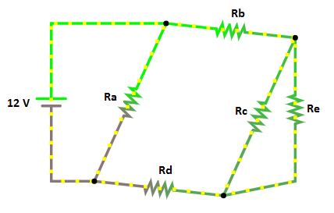**

**FIGURE #1**

**AND FILL THE TABLE #1 AS MENTION BELOW WITH THE DATA AND INSERT 7 SCREENSHOTS:**

|  |  |  |  |
| --- | --- | --- | --- |
| **RESISTANCE** | **POWER(W)** | **VOLTAGE(V)** | **CURRENT(AMP)** |
| **Ra** | **Pa=12Vx12A**  **=144 W** | **12 V** | **12 A** |
| **Rb** | **Pb=6.4Vx3.2A**  **=20.48 W** | **6.4 V** | **3.2 A** |
| **Rc** | **Pc=2.4Vx2.4A**  **=5.76W** | **2.4 V** | **2.4 A** |
| **Rd** | **Pd=3.2Vx3.2A**  **=10.24W** | **3.2 V** | **3.2 A** |
| **Re** | **Pe=2.4Vx0.8A**  **=1.92W** | **2.4 V** | **0.8 A** |
| **RT= 789.5 m ohms.** | | | |
| **IT= 15.2 Amperes.** | | | |

Circuit Screenshot:

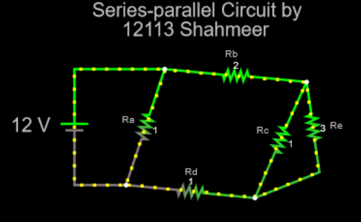

IT Screenshot:

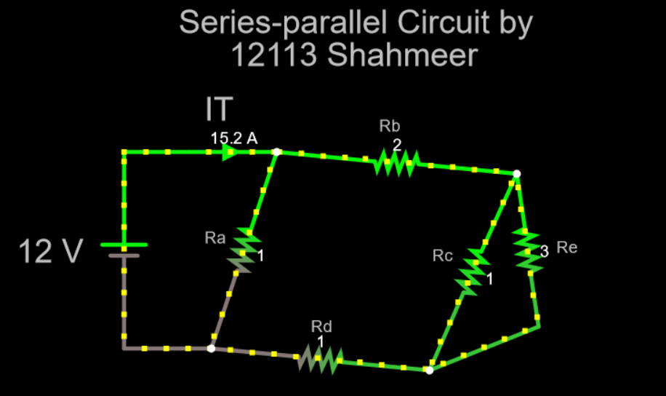

RT Screenshot:

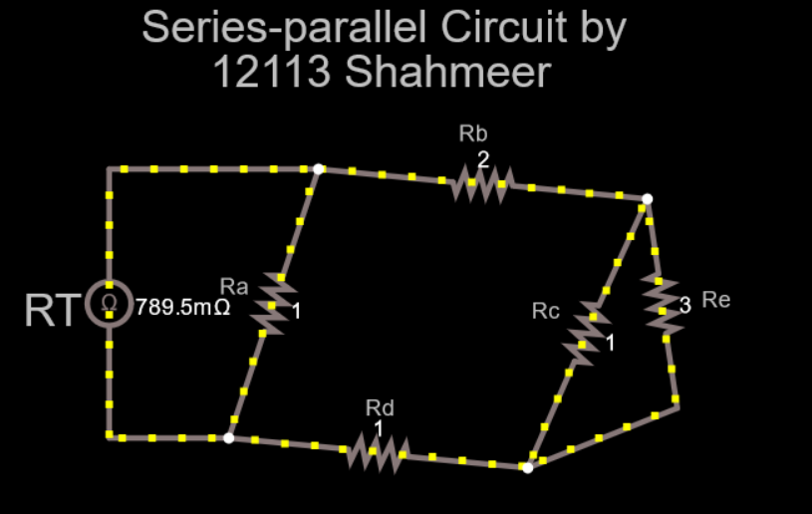

Current Measurement Screenshot:

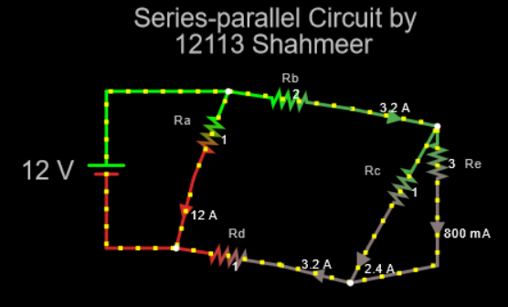

Voltage Measurement Screenshot:

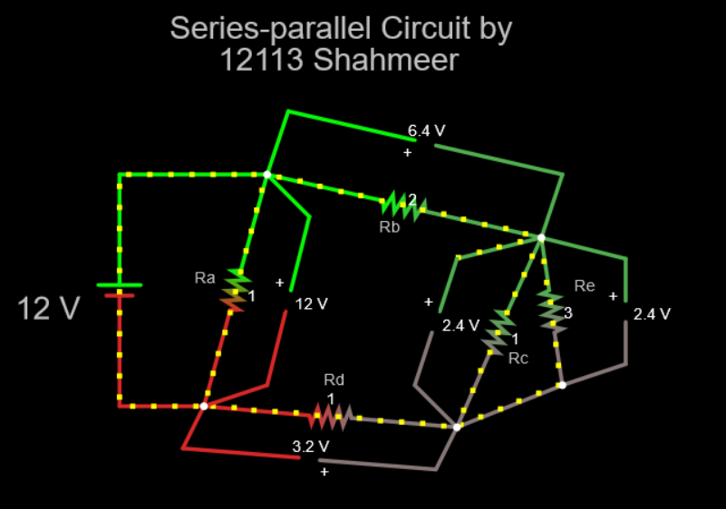

Link:

<https://tinyurl.com/yh4vmbpu>

**Q NO 2: SIMULATE THE FOLLOWING CIRCUIT AS SHOWN IN FIGURE #2: (10)**

**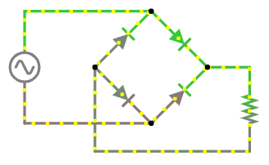**

**INPUT DATA**

**10 HZ**

**15 VPP**

**RESISTOR VALUE IS YOUR LAST DIGIT OF YOUR STUDENT ID IN KILO OHMS IF “0” TAKE 100 Ω.**

**INPUTDATA**

**100 HZ**

**10 VPP**

**FIGURE #2**

* **CALCULATE VP, VRMS & V AVG OF INPUT VOLTAGE AND OUTPUT RECTIFIED VOLTAGE ALSO INSERT THE SNAPS OF INPUT & OUTPUT WAVE FORM WITH THE CIRCUIT MUST BE CLEARLY SHOWN.**

**General Circuit Diagram:**

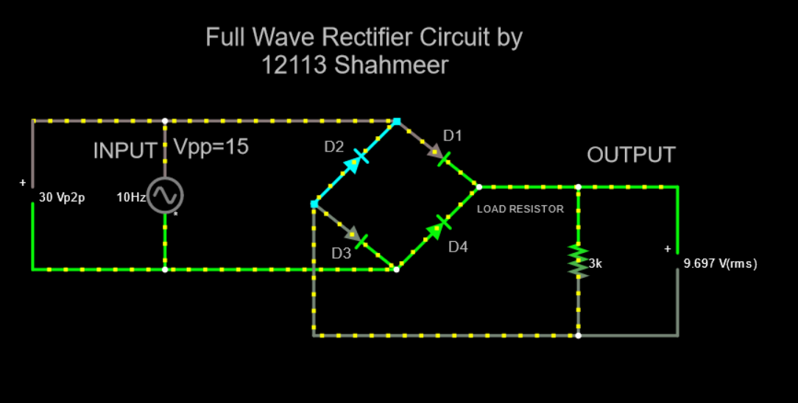

**Peak Voltage Circuit Diagram:**

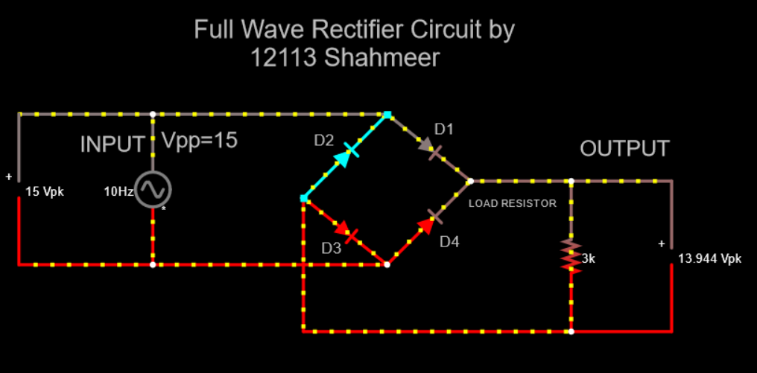

**Input Waveform:**

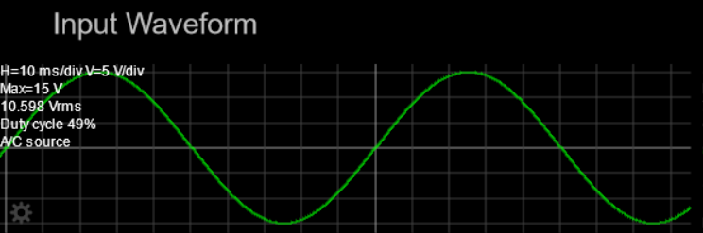

**Output Waveform:**

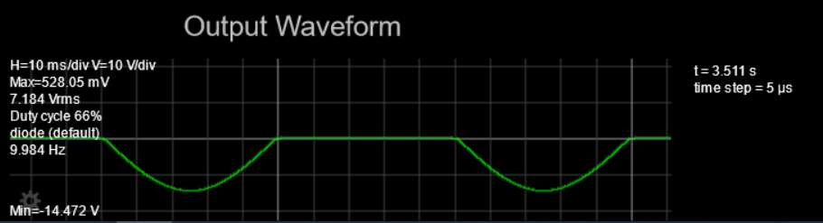

**VP(in)=\_\_\_\_\_\_\_\_\_\_\_15 V\_\_\_\_\_\_\_\_\_\_\_**

**Vrms(in)=\_\_\_\_\_\_\_\_\_\_10.598 V\_\_\_\_\_\_\_\_\_**

**V avg(in)=\_\_\_\_\_\_\_\_\_\_14.535 V\_\_\_\_\_\_\_\_\_**

**VP(out)=\_\_\_\_\_\_\_\_\_\_13.944 V\_\_\_\_\_\_\_\_\_\_**

**Vrms(out)=\_\_\_\_\_\_\_\_\_\_9.697 V\_\_\_\_\_\_\_\_\_**

**DIODE IS USED FOR \_\_\_\_\_\_\_\_ to allow electric current to pass in one direction\_\_\_\_\_\_\_\_\_\_ IN THE CIRCUIT.AND THIS CIRCUIT IS CALLED \_\_\_\_\_\_\_\_\_\_\_\_\_\_ Half wave or Full Wave Rectifier Circuit \_\_\_\_\_\_\_\_\_\_\_\_\_\_\_\_.**

**Link:**

<https://tinyurl.com/yjhr8s54>